Human Centered Curatorial AI Focusing on the Arts

A note on the use of Art: Images of paintings and artworks will be used liberally but only when appropriate for illustrating the point. Expect to see mostly works from the impressionist style, as it is the easiest for me to use for the sake of making points/examples.

- : Abstract
It is not a stretch to call art appreciation one of the great aspects of the human experience, which is what makes building AI systems around it, and other cultural touchstones, such a unique challenge. How does one develop a system that aligns with individual human values, preferences, and emotional expressions? Recent advances in Artificial Intelligence suggest that it’s possible. While the research conducted at institutions such as Rutgers and Stanford have demonstrated the potential for AI to not only generate art, but also to understand the underlying data that drives humanistic values. We believe that the answer lies in the space between man and machine. By developing algorithms that search through vast art collections, find patterns, and make suggestions that human operators can then evaluate. Building such an application requires a strong foundation in Art History, Human Computer Interaction, the Psychology of Aesthetics and more. An attempt at this is the Echo application, a personalized art curation system that presents artworks to the user based on their individual tastes, current mood, and input on what they wish to see.

2.0: Introduction
Digital technologies have fundamentally altered the way we encounter cultual touchstones such as the arts. Museum collections are increasingly digitized, and online platforms display cultural artifacts through opaque feeds. Algorithmic recommendation has become the primary means through which we first encounter music, films, and visual art. Even when we do visit these cultural institutions, we often go with a set plan and knowledge of exactly what to expect. Now, as algorithms become our defacto gatekeeprs of cultural experience, the question about how these feeds are curated, and on what basis. becomes more relevant by the day.
In this context, Human Centered Curatorial AI refers to AI systems that are designed to assist in selecting and presenting artowrks in a way that aligns with human values, preferences, and emotional responses, while ultimately keeping curatorial and creative authority solidly in human hands. Rather than replacing curators or reducing art to a purely algorithmic act, Human Centered Curatorial AI aims to create richer encounter for individuals with the arts by tailroing recommendations and assembling personalized exhibitions that resonate with individuals, while remaining transparent, approachable, controllable, and accountable to both users and cultural institutions.
One of the core challenges of curating and reccommending art with AI systems is the deeply subjective nature of aesthetic preferences and tastes in the arts. We tend to think of one’s taste in art as individualistic, idiosyncratic, and unpredictable; often shaped by personal experiences, mood, culture, and context. Yet a growing body of work suggests that meaningful similarities can be detected in how people respond to artworks, especially when the models incorporate both visual features and relevant metadata. At the same time, largescale art databases and advances in computer vision have made it increasingly feasible to classify artworks based on style , period, artist, and other such attributes, opening the door to more nuanced, data-driven curatorial tools.
However, most existing art recommendation and classification tools are not explicitly designed around human-centered or curatorial principle. They often optimize for click-though or time spent on a given piece, which while each gives some valuable insight, it is not as meaningful as sustained engagement with the user. They treat artworks as individual pieces of a catalog, and provide little explanation as to why a piece was recommended to the end user. This creates some critical risks. Potentially narrowing the user’s exposure to a small subset of a particular, typically popular styles. Reinforcing existing biases in collections and training data. And undermining public trust by offering recommendations that feel broad and opaque. For cultural institutions, these systems may conflict with curatorial goals such as diversity, educational value, or representation of artists from margnizalized groups.
The goal of this paper is to propose a Human Centered Curatorial AI as a framework for designing and evaluating AI-driven art recommendation systems that foreground human experience, agency, and curatorial intent. Using the Echogallery application as a case study, we will explore how user taste profiles, mood signals, and explainable recommendation techniques can be combined to generate personalized art selections that remain legible and adjustable to users.
Specifically we ask
- How can AI-driven systems infer and represent individual art preferences in a way that is both expressive and understandable to users.
- How can recommendations be explained or visualized so that users grasp why particular works were selected?
- How human centered curatorial principles, such as diversity, balance, and narrative coheerence, be encoded into recommendation logic without sacrificing personalization?
To address these questions, I’ve designed and implemented a prototype recommendation system that combines visual embeddings of artworks, metadata-level features such as style, period, and artist, and an interactive profiling process that evolves with user feedback. This system generates personalized sets of artworks and accompanying explanations that highlight both aesthetic and semantic relationships. I will, likely after submitting this as a final paper, begin an initial evaluation of the application focusing on user perceptions of relevance, diversity, and explainability, as well as the perceived role of the AI system in relation to human curatorial agency.
The potential contributions of this work are threefold.
- It will articulate a conceptual framing of Human Centered Curatorial AI that integrates insights from human-computer interaction, explainable AI, and curatorial practicie in the arts.
- It presents the design of the Echogallery system, which I rename as Echo, as an instantiation of this framework, detailing its data pipeline, modeling choices, and interaction design.
- Offer emperical and reflective findings on how users experience AI mediated art recommendation when explanation and control are treated as core design principles, rather than as an after thought.
The remainder of this paper will focus on the methadology of the application. The design of the Echogallery AI reccommendation system will then be discussed, as well as relevants works that make me believe thatit is in fact possible. Keeping in mind that the application will likely only be in rough alpha testing state by the time this paper is turned in, the results from the initial build/local test of the application, as well as forecasting a potential, actionable plan for testing the system in the field, and next steps for the project as a research project will be used to cover the results section of the aoo. And a discussion of the results so far, and their potential beyond.

3.0 Related Works
For the intents and purposes of this paper, I’m going to classify the research along 3 lines. 0. Human Behavior and its predictability in relation to the arts. 1. Art and Artificial Intelligence. 2. The intersection of the two.
A 2021 study in Nature of Human Behavior demonstraed that a computer could identify and predict an individual’s preferences in paintings by analyzing visual features. In their experiment over 1500 individuals rated artwork from various styles such as impressionism, cubism, abstract, etc. And the AI model learned which visual attributes. Low level (colors/contrast), and high level (how dynamic/still a painting looks for example). And how these influenced a person’s taste. The model clustered vieweres into a few broad taste groups; for example those who prefer realistic scenes vs those who prefer abstract, or those who prefer solid color tones, to vibrant color schemes. This suggests that while art appreciation is subjective, there are still patterns of preference that we can extract. Moreover, the success of similar algorithms applied to other fields of the arts, such as the music recommendation algorithms for applications like Pandora or Spotify, tell us that this shouldn’t be terribly difficult with the right input variables. Last as it pertains to this study, the researchers noted that there are still individual quirks, such as an individual’s unique experiences and derived meanings attached to individual artworks, which suggest that the model would still need fine tuning in order to be successful with each individual user.
There was a point early on in the development of this project where I briefly wondered if I’d bitten off more than I could chew. Luckily, one of the turning points in this project was the discovery was the work of the Rutgers AI and Arts lab. At the core of their research was the idea that deep neural networks could analyze visual art at scale. Deep convolutional models with batch normalization and ResNet-style skip connections make it feasible to train on tens of thousands of digitized paintings, learning rich style represenations that support tasks such as large-scale style classification, mapping artworks into a continuous “shape” of art history, and quantifying creativity as a function of originality and influence within the art historuical network. These same representational capacities allowed the lab to operationalize art history concepts such as style, period, and visual elements, directly from pizels rather than hand crafted features. Building upon GANs, the lab proposed the idea of Creative Adversarial Networks (CAN) and the AICAN system, which can modify the standard adversarial objectective sp that the generator not only produces images that are classified as art, but is also penalized for adhering too closely to known style categories, implementing some of Martindale’s theory that artistic innovation arises from controlled deviation of stylistic norms.
Or to summarize the above in one brief sentence. They proved that classifying art with AI techniques was well within the range of what is possible. With a conversation with Dr Elgammal giving me both the critical insight and tools necessary to build the AI model that Echogallery is layered upon.

4.0: Methodology
At the time of writing this, Echogallery is implemented as a working prototype and is entering its initial alpha testing phase. The methodology discussed in this section outlines the planned approach for evaluating the system and answering the research questions. The study design combines the technical architecture of the Human Centered Curatorial AI system, and a planned user study to assess recommendation quality, explainability, and perceived agency.
Note: The below study/methodology is all hypothetical but is something that I would appreciate the chance to do formally.

4.1 Research Design Overview
The research is planned as a mixed method study in two phases.
- Phase 1: System refinement and alpha testing
The current Echogallery prototype will be iteratively refined through informal alpha testing with a small group of users (classmates, friends, colleagues, and collaborators). This phase will focus on usability, performance, and basic accuracy of recommendations and explanations.
- Phase 2: A formal user study
After alpha stabilization, a structured user study will be conducted to evaluate how people experience Echogallery. Participants will complete a taste profiling process, receive personalized recommendations under different system configurations, and provide both quantitative ratings and qualitative feedback.
The methodology below focuses on Phase 2, assuming the prototype has reached a stable state suitable for empirical evaluation.
4.2 System Architecture and Data Pipeline
Echogallery is implemented as an AI driven art recommendation system that combines visual and metadata-based representations of artworks with an interactive taste profiling interface. Each artwork is mapped into a shared embedding space using a pretrained vision model and metadata features including style, period, and artist. The recommendation engine retrieves candidate artworks based on similarity to the user’s current taste vector and re-ranks them using simple diversity and curatorial constraints. An explanation module surfaces key factors driving each recommendation as short natural language justifications.
A full mathematical description of the embedding construction, scoring function, and explanation logic is provided in Section X.

4.3: Planned User Study Design
4.3.1: Participants
The planned study will recruit adult participants from the university community and online channels. The target is a sample that includes both casual art viewers and participants with moderate interest in the arts in order to reflect the target demographic.
- The initial anticipated sample size would be 20-40 participants, depending on the feasibility of recruitment.
- Basic demographics and background data (age, gender, prior museum attendance, self-rated art expertise, and familiarity with AI recommendation systems), will be collected in a pre-study survey.
4.3.2: Conditions
Participants will interact with Echogallery at a to be selected partner museum under two conditions
- A baseline recommender (the control):
  - This would be pure, similarity based ranking of the museum’s works with minimal diversity constraints.
  - There would be no explicit textual explanations.
- Human Centered Curatorial AI (Treatment)
  - The Echogallery application’s functionality is enabled
  - Explanations for each recommendation are shown.
A within-subjects study will be conducted where certain participants experience both the app and the control in order to effectively compare the two.

4.3.3: The planned procedure
- Consent and pre-study survey: Participants will review and information sheet, provide consent, and complete the demographic/background questionnaire.
- Taste profile: Participants will use Echogallery’s built-in taste quiz and select a session mood/direction.
- Interaction: Participants will be assigned to either the control or treatment first. They will browse recommendations for a fixed time window (30-45 minutes in a gallery assigned to them by the “taste quiz”), or until they’ve interacted with a minimum number of artworks. All interactions will be logged.
- Evaluation: A short questionnaire will ask about relevance, diversity, trust, and explanation quality (if it’s applicable to said participant).
- Post study reflection: Participants will answer open-ended questions comparing the conditions and commenting on how “curatorial” or “algorithmic” each experience felt. When feasible, brief follow-up interviews may be conducted.
The expected total time each participant would be involved in the study would be 1 – 1.5 hours.

4.4: Measures and Planned Data Collection
4.4.1: Quantitative measures: For each condition, the following metrics will be collected
- Perceived relevance: Likert-scale items on how well recommendations matched tastes.
- Perceived diversity: Non-repetitiveness, variety of styles/ideas.
- Explainability and understanding: For the treatment case only.
- Trust and perceived control: The users felt like they could guide what the system showed, and curators felt like the descriptions mirrored the direction they wished for their museums/galleries.
- Behavioral engagement: Number of artworks viewed, likes/dislikes, and time spent on the application.
All interaction events will be logged for analysis.

4.4.2: Qualitative analysis: Once the data is collected, the plan is to
- Open-ended survey responses after each condition and at the end of the session.
- Optional short interviews with a subset of participants.
These will be used to understand how participants interpret the system’s role, explanations, and curatorial qualities.

4.5: Planned Data Analysis
4.5.1: Quantitative Analysis: Once data points are collected, the plan is to
- Compute descriptive statistics for each measure by condition.
- Use paired statistical tests such as paired t-tests or non-parametric equivalents, to compare control vs treatment on relevance, diversity, and perceived agency.
- Explore correlations between explanation ratings and trust agency
- Conduct explanatory subgroup analyses, art-experts vs non-experts, if the sample size allows.

4.5.2: Qualitative Analysis: Qualitative analysis will follow a thematic analysis approach
- Responses will be coded inductively to identify themes related to perceived fit of recommendations, usefulness of explanations, feelings of being curated and concerns or discomfort.
- Themes will then be related back to quantitative findings, such as comparing comments from participants with high vs low perceived control.

4.6: Ethical considerations and current status
This methodology is proposed for a future formal study. Before data collection begins, the study will be submitted for review to the appropriate institutional review board and/or ethics committee, if that ends up being required for this to continue, as is the goal.
Participants will provide informed consent, may withdraw at any time, and will have their data pseudonymized. Artworks will be used in accordance with dataset and museum licensing terms.
At the moment, Echogallery is in the final section of its base development phase. Alpha testing will be possible and begin informally within the calendar year, and feedback will be factored into the initial study design.

5: The System
I’m going to explain this in two parts, layman’s terms, and technical.
Think of the recommendation system as a personalized curator who slowly learns your taste in art then walks you through a museum, pointing out pieces you’re likely to appreciate. At its core, it’s all math. We translate your tastes and the artworks themselves into points in the same “taste space’, then look for artworks that are close to that point.
The first thing the system does is build a starting taste profile from an introductory quiz where you set styles you like such as Impressionism or Ukiyo-e, preferred moods, and certain color palettes. The system treats each of those as centers in this space and mixes them together according to how much you claimed to like each. That mixture becomes the basis of your long-term taste vector, a single mathematical summary of your stable preferences. Later, in the equations, this shows up as a weighted blend of style, mood, and color centroids.
Next, the system refines this with your actual behavior. Every time you like, save, or skip an artwork, nudges your taste vector. Liked pieces pull your profile toward their location in the space, disliked pieces push it away. On top of that. Each session picks up or implies a given mood, for example you may want to see something calming after a stressful day at work, or something romantic because you’re out on a date, these factors temporarily shifts your profile toward artworks that match that vibe.
To summarize the above and roughly speaking
$$quiz based vector+history based vector+session mood vector=Final User Embedding$$
Once we have this final embedding, we use it to search the art collection, either ours, or that of a museum/gallery that you’re visiting. In our all artworks are pre-encoded as vectors using a vision-language model, specifically CLIP, and are stored in a fast index. The system first retrieves a set of candidate artworks whose vectors are associated with yours, which means they’re broadly similar in style, mood, and visual content. Then, for each candidate, it computes a score made up of several parts. How close the artwork is to your taste in the embedding space, how well its metadata matches your preferences (style tags, color, era, etc) and a term that balances popularity with novelty so you see a mix of hits and fresh discoveries.
Finally, the system learns how to weigh these factors by looking at real user behavior. If people tend to click on items that match their style more than their color preferences, the model will learn to give style a higher weight. We can train this using standard techniques such as logistical regression or pairwise ranking, treating each interaction as a small hint about which artworks should be ranked higher/lower. Because we build the final score as a sum of interpretable pieces, we can also make recommendations in human terms such as “We recommended you look at the Song of the Lark because you’ve demonstrated an appreciation for the impressionist style, soft, yet focused colors, and themes of hope and wonder”
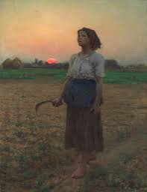
Now, I’ll explain this in mathematical depth, whilst attempting to use a flow of artwork to demonstrate the progression of the app. Now, for our intents and purposes, we’re going to progress through the below as if we’re doing this entirely online, since the works used to illustrate the point are quite literally scattered throughout the world.
Phase 0:
Notation
- There is a baseline set of artworks $i ∈\{1, …, N\}$
- The vector space dimension of the CLIP embedding size: d
- User index: u
Core Vectors
- Artwork embedding (CLIP space): $e_{i}∈R^{d}$
- Artwork metadata features: $m_{i}∈R^{k}$; style, genre, museum, era, etc.
The Full Artwork Vector being represented by
$$x_{i}=[\begin{matrix}e_{i} \\ m_{i}\end{matrix}]∈R^{d+k}$$
When we normalize the CLIP embeddings
$${e`}_{i}=(\frac{e_{i}}{\left( | e_{i}|)\right)2}$$
1. Offline artwork representation and style centers.
From the dataset we precompute style/genre centroids in CLIP space for interpretability
Let X_{s} be the set of artworks with style s. Then:
$$c_{s}=(\frac{1}{|X_{s|}})\sum_{i∈X_{s}}{w_{j}^{-}e_{j}}$$
Similarly for mood, color families, etc.
$$c_{r}^{(mood)}, c_{c}^{(color)}, …$$These c* vectors will come in handy for explanations and diagrams such as “Impressionism Center”, “Blue/cool color palette center”, and “Calm mood center”.
Now, for our intents and purposes. Let’s assume that the below is the starting point for the hypothetical user of this application, and is the painting most attuned to where they are in this process at the moment.
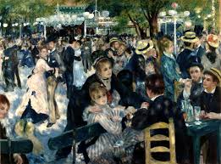
Renoir: Bal du moulin de la Galette
2. The user takes the taste quiz to begin forming the long term taste vector.
The quiz works with the following weights
- Style weights: $α_{u}^{(style)}ϵR^{s}$
- Style weights: $α_{u}^{(mood)}ϵR^{R}$
- Style weights: $α_{u}^{(color)}ϵR^{C}$
Where each vector is normalized as
$$\sum_{s}{α_{u, s}^{(style)}=1, } α_{u, s}^{(style)} ≥0$$
(and similarly for mood/colors).
We map quiz preferences into CLIP space as a mixture of centroids:
$$t_{u}^{\left(\text{style}\right)}=\sum_{s=1}^{S}{α_{u,s}^{\left(\text{style}\right)}} c_{s} \\ t_{u}^{\left(\text{mood}\right)}=\sum_{r=1}^{R}{α_{u,r}^{\left(\text{mood}\right)}} c_{r}^{\left(\text{mood}\right)} \\ t_{u}^{\left(\text{color}\right)}=\sum_{c=1}^{C}{α_{u,c}^{\left(\text{color}\right)}} c_{c}^{\left(\text{color}\right)}$$
Combine into one quiz-derived taste vector:
$$t_{u}=w_{\text{style}} t_{u}^{\left(\text{style}\right)}+w_{\text{mood}} t_{u}^{\left(\text{mood}\right)}+w_{\text{color}} t_{u}^{\left(\text{color}\right)}$$
Optionally normalize:
$${\tilde{t}}_{u}=\frac{t_{u}}{∥t_{u}∥_{2}}$$And to summarize the above: Box Quiz Preference Weights ($α$ vectors) “Mix with style/mood/centroids” “Long term taste vector ${\tilde{t}}_{u}$”
3. Interaction history Behavioral Taste Vector
Let L_{u} be artworks the user liked/saved and D_{u} represent artworks that have been disliked/skipped. We start by defining a positive history vector
$$h_{u}^{+}=(\frac{\left(1\right)}{Z_{u}^{+}})\sum_{i∈L_{u}}{w_{i}^{+}}{\tilde{e}}_{i}$$
Where $w_{i}^{+}$can encode recency or strength and $z_{u}^{+}$ is the normalizing constant.
We then subtract a “dislike” component.
$$h_{u}^{-}=(\frac{\left(1\right)}{z_{u}^{-}})\sum_{j∈D_{u}}{w_{j}^{-}}{\tilde{e}}_{j} \\ h_{u}=h_{u}^{+}-λ_{\text{neg}}h_{u}^{-}$$
Normalize:
$${\tilde{h}}_{u}=\frac{h_{u}}{∥h_{u}∥_{2}}$$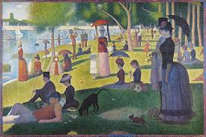
Seurat: A Sunday Afternoon on the Island of La Grande Jatte
This would be the point where pieces like the above would begin to enter the picture

4. Mood/Session state session vector : At the time of recommendation, the user may choose a current mood, r (calm, energetic, etc.) or vibe. We then map that to CLIP space using the precomputed centroids:
$$z_{u}^{(session)}= c_{r}^{(mood)}$$
Or if the mood is a mixture
$$z_{u}^{(session)}= \sum_{r}{β_{u,r}^{(session)}}c_{r}^{(mood)}$$
5. The final user embeddings
We blend three components:
- Long-term quiz taste: ${\tilde{t}}_{u}$
- Behavior taste: ${\tilde{h}}_{u}$
- Current session mood: $z_{u}^{\left(\text{session}\right)}$
$$u_{u}=γ_{\text{quiz}} {\tilde{t}}_{u}+γ_{\text{hist}} {\tilde{h}}_{u}+γ_{\text{sess}} z_{u}^{\left(\text{session}\right)}$$
with $γ_{\text{quiz}}+γ_{\text{hist}}+γ_{\text{sess}}=1$.
Normalize:
$${\tilde{u}}_{u}=\frac{u_{u}}{∥u_{u}∥_{2}}$$
Diagram hook:
Three arrows into a “User Embedding” box labeled ${\tilde{t}}_{u},{\tilde{h}}_{u},z_{u}^{\left(\text{session}\right)}$→ combined vector ${\tilde{u}}_{u}$.
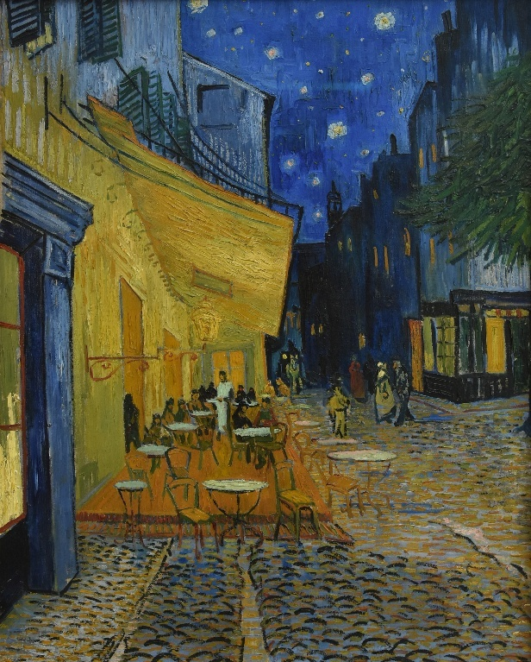
Van Gogh: Café Terrace at Night
The sort of results I’d expect you’d see were you to say you were in a more contemplative mood, which is generally associated with darker color schemes in art circles.
6. Candidate retrieval (fast search)
We store all artwork embeddings ${\tilde{e}}_{i}$in a FAISS index.
Given user vector ${\tilde{u}}_{u}$, we get a candidate set $C_{u}$by nearest neighbors in cosine space:
$$C_{u}=\text{ANN_topK}({\tilde{u}}_{u},\{{\tilde{e}}_{i}\}_{i=1}^{N},K_{\text{cand}})$$
Cosine similarity is:
$$\text{cos}({\tilde{u}}_{u},{\tilde{e}}_{i})={\tilde{u}}_{u}^{⊤}{\tilde{e}}_{i}$$
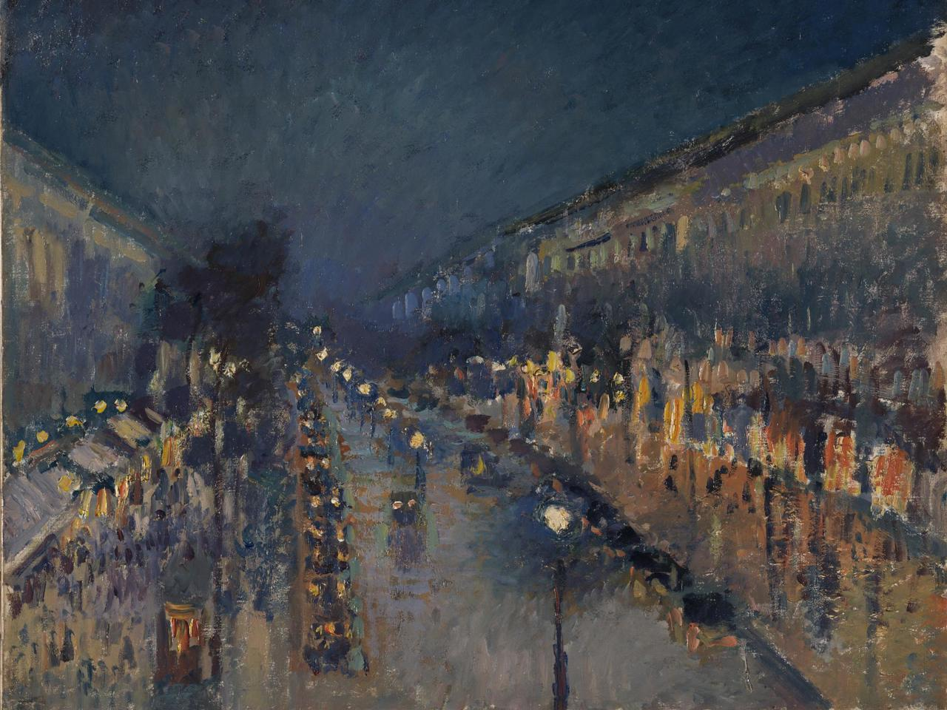
Pissarro | The Boulevard Montmartre at Night
Highlights the users desire to see impressionist cityscapes at night with lights and movement.

7. Scoring function for each candidate
For each artwork $i∈C_{u}$, we compute several components.
7.1 Content similarity score
$$s_{\text{content}}(i,u)={\tilde{u}}_{u}^{⊤}{\tilde{e}}_{i}$$
7.2 Metadata affinity score
Let $f(i,u)∈R^{p}$be a feature vector encoding “matches” between artwork metadata and user preferences, e.g.:
- does style of $i$match user’s top styles?
- color palette overlap score
- era preferences, etc.
Let $θ_{\text{meta}}∈R^{p}$be learned weights.
$$s_{\text{meta}}(i,u)=θ_{\text{meta}}^{⊤}f(i,u)$$
7.3 Popularity / novelty term
Let:
- ${\text{views}}_{i}$= total views/saves
- ${\text{Seen}}_{u}$= set of items user already saw
Popularity:
$$\text{pop}(i)=log⁡(1+{\text{views}}_{i})$$
Novelty (distance from user’s seen items):
$$\text{novelty}(i,u)=\underset{j∈{\text{Seen}}_{u}}{min⁡}∥{\tilde{e}}_{i}-{\tilde{e}}_{j}∥_{2}$$
Combine:
$$s_{\text{explore}}(i,u)=γ_{\text{pop}}\text{ pop}(i)+γ_{\text{nov}}\text{ novelty}(i,u)$$
7.4 Full score
$$S(i,u)=w_{\text{content}} s_{\text{content}}(i,u)+w_{\text{meta}} s_{\text{meta}}(i,u)+w_{\text{explore}} s_{\text{explore}}(i,u)$$
Top-$K$ recommendations:
$${\text{Rec}}_{K}(u)=\underset{i∈C_{u}}{arg topK⁡}S(i,u)$$
Diagram hook:
For each candidate artwork:
(1) “Cosine similarity block” → $s_{\text{content}}$
(2) “Metadata match block” → $s_{\text{meta}}$
(3) “Popularity/novelty block” → $s_{\text{explore}}$
Then sum into a “Final Score” node $S(i,u)$, feeding into a sorting block.
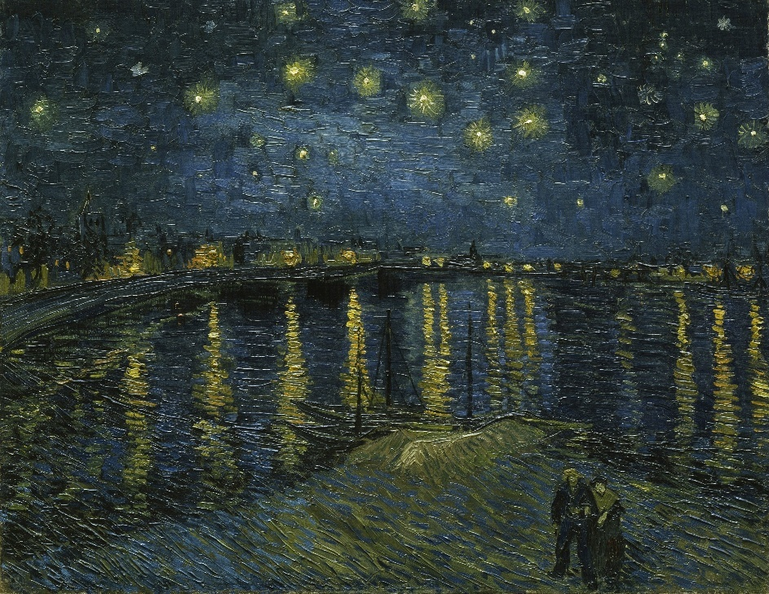
Van Gogh | Starry Night Over the Rhone
Follows a similar pattern of nocturnal cityscapes, but places somewhat more of an emphasis on natural features of the city.
8. Learning the scoring weights (logistic / pairwise)
If you want to be precise about training:
We model probability of a positive interaction (click/save) as:
$$P(y=1∣i,u)=σ(S(i,u))\text{where}σ(z)=\frac{1}{1+e^{-z}}$$
Given a dataset of events
$$D=\{(u_{t},i_{t},y_{t})\}_{t=1}^{T},y_{t}∈\{0,1\},$$
we minimize logistic loss:
$$L(Θ)=-\sum_{t=1}^{T}{\left[y_{t}log⁡σ(S(i_{t},u_{t}))+(1-y_{t})log⁡(1-σ(S(i_{t},u_{t})))\right]}+λ∥Θ∥_{2}^{2}$$
where $Θ$collects parameters like $θ_{\text{meta}},w_{\text{content}},w_{\text{meta}},w_{\text{explore}},γ_{\text{pop}},γ_{\text{nov}}$, etc.
If you prefer pairwise ranking (BPR-style):
For each event, pick a positive item $i^{+}$and a negative/unseen item $i^{-}$, and minimize:
$$L_{\text{BPR}}(Θ)=-\sum_{t}{log⁡σ(S(}i_{t}^{+},u_{t})-S(i_{t}^{-},u_{t}))+λ∥Θ∥_{2}^{2}$$
Diagram hook:
Training diagram = “Interaction log → feature generator → loss block (logistic/BPR) → parameter update.”
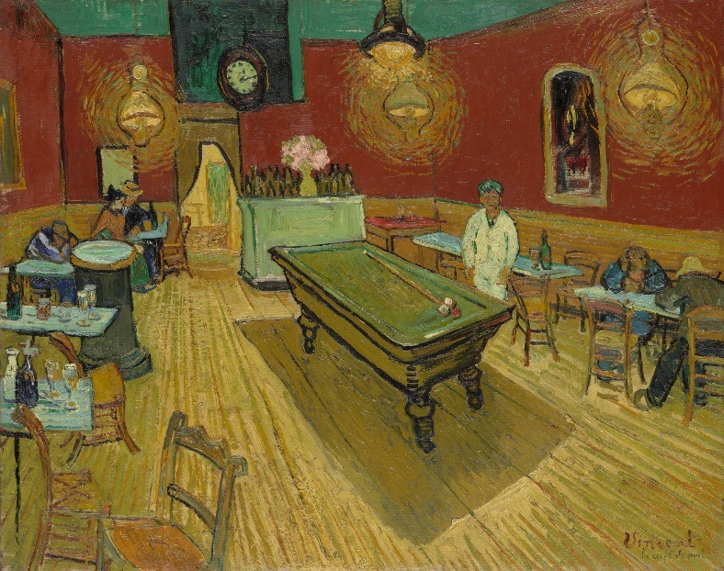
Van Gogh: The Night Café
If the user implies the same “city evening” vibe, but implies a desire to see interior pieces.

9. Built-in explainability hook
Because we wrote:
$$S(i,u)=\sum_{k}{w_{k}} g_{k}(i,u)$$
(where $g_{k}$could be “content similarity”, “style match”, “color match”, “popularity bonus”, etc.), we can decompose the score into interpretable contributions:
$${\text{contrib}}_{k}(i,u)=w_{k} g_{k}(i,u)$$
These can be directly mapped to explanations like:
- “+0.42 because this is close to your Impressionist taste”
- “+0.18 because it has cool blue tones you prefer”
- “+0.05 because it’s popular, but still novel for you”
Diagram hook:
For a single recommended artwork, show a bar chart of contributions ${\text{contrib}}_{k}(i,u)$.
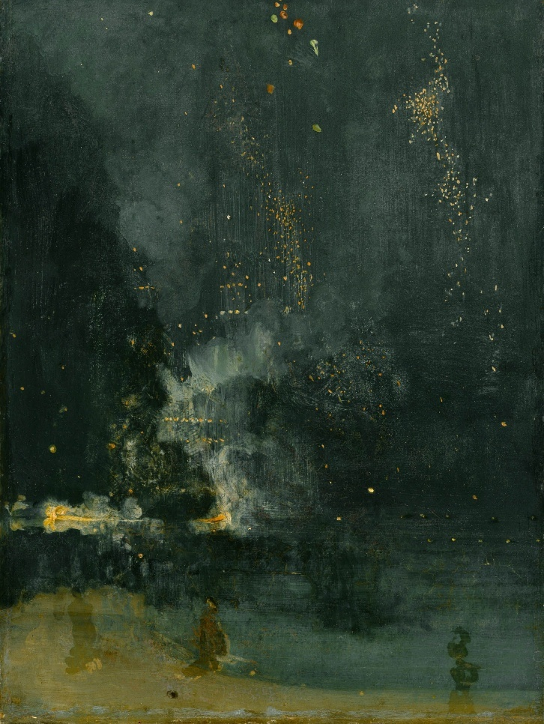
James McNeill Whistler | Nocturne in Black and Gold – The Falling Rocket
This would be the conclusion of the algorithm’s run, and would be the painting most reflective of the user’s tastes/the baseline for a potential tour.

6: Anticipated Results
A note to the grader: Because Echogallery is currently in an early development phase and the formal user study has yet to be conducted, the results discussed here are anticipated rather than empirical. They are grounded in the methodology proposed above are representative of anticipated results.
First, it’s expected that the Human Centered Curatorial AI (HCCAI) of Echogallery will perform at least as well as a baseline similarity recommendation system in terms of perceived relevance, if not slightly better. By embedding user taste profiles in the same joint-visual semantic space as the artworks, and updating these profiles based upon individual user feedback, the expectation is that the system should be able to provide more targeted and relevant recommendations top individual users.
Second, stronger differences are anticipated in perceived diversity and novelty. Because the HCCAI condition explicitly incorporates curatorial constraints, such as promoting the spread of certain styles, or occasional highlights of the works of a particular styles/periods/artists, participants will occasionally see more of a particular style than their taste profile would normally recommend to them when visiting a particular institution, though this will likely be optional should the application become more than a “proof of concept”.
Third, the presence of explanations in the HCAI condition is expected to improve the perceived transparency and understanding. By surfacing concrete factors such as shared style, color palette, or alignment of a chosen mood, and then relating new recommendations to previously liked works, the explanation module should help participants make sense of why specific artworks were shown. Quantitatively, this should appear in higher scores on explanation related items, and in positive correlations between explanation quality, trust, and perceived agency. With qualitative feedback being expected to include descriptions of the system as “thoughtful” or “guided”.
Fourth, the HCCAI configuration is anticipated to increase trust and perceived control relative to the baseline of the simple baseline similarity recommendation system. The combination of an explicit taste profiling phase, real-time responsiveness to likes and dislikes, and visible explanations should create a sense that the system is responsive to user input rather than operating as an opaque feed. Participants are expected to report a greater ability to steer what they see in the HCCAI condition, and interaction logs may show higher engagement such as more likes/dislikes/artworks explored, when explanations and curatorial diversity are present.
Qualitative data is expected to surface several recurring themes. Some participants may describe Echogallery in the HCCAI mode as feeling more “curated” and “museum-like”, whereas the baseline is expected to be characterized as “algorithmic”. Explanations may be described as helpful when they clearly connect to the visible features of the artworks or resonate with the users, but potentially annoying or redundant when they are phrased too generically, thus highlighting a design challenge for future versions of the application.
It is also anticipated that some participants will use the system to articulate or discover aspects of their own tastes, such as realizing an unexpected preference for a particular color palette or discovering an appreciation for the works of an artist they’d previously written off. While others are expected to voice skepticism about the system’s ability to capture complex aesthetic preferences or concerns about being put into a box. These anticipated themes will inform the discussion of both the promise and limitations of Human Centered Curatorial AI.
Lastly, it is expected that feedback will demonstrate that there is a lot of room for further research and improvements of the application. Echogallery, by nature, is an application that improves with time and interaction. The first set of experiences let’s say three for example, with the application are expected to feel somewhat more wooden than the fourth interaction onwards, as the application gathers data on how to more effectively curate the individual users.

7: Discussion
The Echogallery prototype and proposed evaluation together suggest a reframing of algorithmic art recommendation as a form of Human Centered Curatorial AI, rather than a purely utility driven personalization problem. By explicitly modeling user tastes, session mood, and curatorial constraints such as stylistic and temporal diversity, the system attempts to balance relevance with exploration and expose users to a broader slice of a collection, rather than a standard similarity-based recommendation system could.
The incorporation of explanations grounded in visible and semantic features further positions the AI as a partner, in sense making. Instead of merely presenting items, it offers reasons that help users understand and refine their own preferences. Although the formal study still needs to be carried out, the design and anticipated results outlined in this paper point toward an interaction pattern where users experience the system less as an opaque feed, and more as a dialogic, semi-curatorial presence that can be questioned, steered and occasionally resisted.
At the same time, the work highlights important limitations and tensions that any Human Centered Curatorial AI must confront. Technically, the system will operate on biased and incomplete datasets, relying heavily on pretrained models whose representations may not align with the nuances of art history. And will offer explanations that are largely feature level rather than interpretive. These constraints bind what kind of an understanding that the AI can possibly claim to have.
Conceptually, optimizing for individual satisfaction can come into conflict with broader curatorial goals of institutions, such as representing marginalized groups or up and coming artists, fostering critical reflection, or challenging the user’s comfort zone. The proposed methodology would is necessarily small-scale and laboratory like, and cannot substitute for longitudinal, real world deployments or participatory design with artists and curators. Thus, Echogallery should be regarded as less as a finished solution, and more as a testbed for exploring how explainability, controllability, and curatorial values might be encoded, surfaced, and negotiated in AI systems that mediate access to the arts. Systems that if designed carelessly, risk automating cultural authority. But if designed thoughtfully, can help to redistribute it.

Conclusion
This paper has presented Echogallery as a practical example of Human Centered Curatorial AI, framing art recommendation not merely as a prediction problem but as collaborative, curatorial process between humans and machines. By combining user taste profiles, mood signals, visual-semantic embeddings, diversity aware ranking, and feature-grounded explanations, the system is designed to support art encounters that feel both personal and understandable.
The planned evaluation will examine how these choices shape perceived relevance, diversity, trust, and agency. And will help clarify where personalization aligns with, or pushes against, broader curatorial and cultural goals. Even at this early stage, the architecture and study design outline a practical path toward recommendation systems that behave less like opaque feeds, and more like conversational partners in art discovery.
Beyond this specific prototype, the work is intended as an inviting foundation for others. Researchers can adapt the framework, joint embeddings, curatorial constraints, explanation templates, to parallel domains such as music, literature, or film. Practitioners in museums and cultural institutions can treat the Echogallery pipeline as a starting point for visitor facing tools that align algorithmic behavior with institutional values.
On a final, personal note. Another week would’ve seen this application ready for alpha testing, and I fully intend to push it to that state. Writing this report simply took precedence. I hope to be able to continue working with Clemson on this.

Sources
California Institute of Technology. (2021, June 16). Computers predict people's tastes in art. ScienceDaily. Retrieved December 9, 2025 from www.sciencedaily.com/releases/2021/06/210616143236.htm

Saleh et all (2014, August 14th) Toward Automated Discover of Artistic influence
https://arxiv.org/pdf/1408.3218

Saleh, Elgammal (2015, May 5th) Large-scale Classification of Fine-Art Paintings: Learning The Right Metric on The Right Feature
https://arxiv.org/pdf/1505.00855

